Rocket Motors

Requirement Report

Author: <Author name>

Revision: 0.1

|  |  |
| --- | --- |
| NA |  |
| NA | Date: marzo 18, 2019 |

**Revision History**

|  |  |  |  |
| --- | --- | --- | --- |
| **Revision** | **Date** | **Reason For Changes** | **Author** |
| 1.0 | Jan 02, 1990 | <Release> | <Author Name> |
| 0.1 | Jan 01, 1990 | <Initial draft> | <Author Name> |
|  |  |  |  |

**Table of Contents**

Microsoft Word users please click here and press F9 to create Table of Contents.

OpenOffice.org users please remove this text and select Insert Table of Content from menu.

**Table of Figures**

Microsoft Word users please click here and press F9 to create Table of Contents.

OpenOffice.org users please remove this text and select Insert Table of Content from menu.

**Executive Summary**

This section previews the main points of a report. The executive summary contains enough information for a reader to get familiarized with what is discussed in the full report without having to read it.

# Introduction

## Purpose

<This document provides requirements with their properties including requirement id, requirement name, requirement text and the dependencies.>

## Scope

<Provide a short description of the system being specified and its purpose, including relevant benefits, objectives, and goals.>

## Overview

<Describe what the document contains and explain how the document is organized>

# 1 Business requirements

## BR-1 Business requirement1

The system shall do term1

### BR-1.1 Business requirement2

The system shall do term2

**Derived:**

|  |  |
| --- | --- |
| 953326272.png | FR-1.1 Functional requirement2 |

|  |  |
| --- | --- |
| -202000033.png | NFR-1.1 Design constraint1 |

**Traced From:**

|  |  |
| --- | --- |
| 953326272.png | FR-1.1 Functional requirement2 |

|  |  |
| --- | --- |
| 1739483047.png | Use case1 |

|  |  |
| --- | --- |
| -202000033.png | NFR-1.1 Design constraint1 |

### BR-1.2 Business requirement3

The system shall do term2

**Derived:**

|  |  |
| --- | --- |
| 953326272.png | FR-1.2 Functional requirement3 |

|  |  |
| --- | --- |
| 967133216.png | NFR-1.2 Interface requirement1 |

|  |  |
| --- | --- |
| 2125216939.png | NFR-1.3 Performance requirement1 |

**Traced From:**

|  |  |
| --- | --- |
| 953326272.png | FR-1.2 Functional requirement3 |

|  |  |
| --- | --- |
| 1739483047.png | Use case2 |

|  |  |
| --- | --- |
| 1739483047.png | Use case3 |

|  |  |
| --- | --- |
| 967133216.png | NFR-1.2 Interface requirement1 |

|  |  |
| --- | --- |
| 2125216939.png | NFR-1.3 Performance requirement1 |

### BR-1.3 Business requirement4

The system shall do term2

### BR-1.5 Registro Usuario

Crear a cada usuario un ID para reconocerlo en la aplicación y garantizar así un uso de la base de datos por parte del usuario.

**Risk:**

Medium

**Verify Method:**

Analysis

**TODO:**

Proporcionar a cada usuario un ID unico

#### BR-1.5.1 Nombre del Usuario

#### BR-1.5.2 Cambiar Contraseña

#### BR-1.5.3 Borrar Cuenta

#### BR-1.5.4 Foto de Perfil

# Appendix A: Diagram

## 1 Business requirements

NA

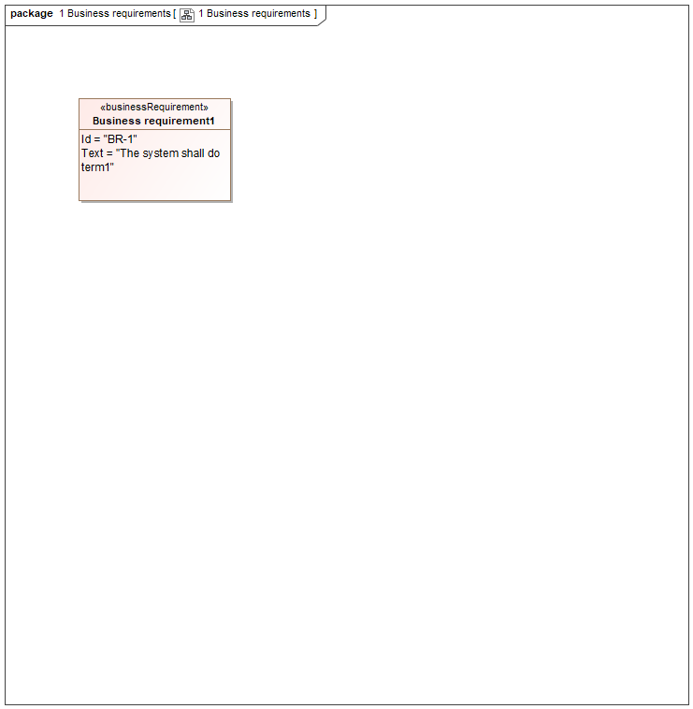

1. 1 Business requirements

## Business requirement diagram

NA

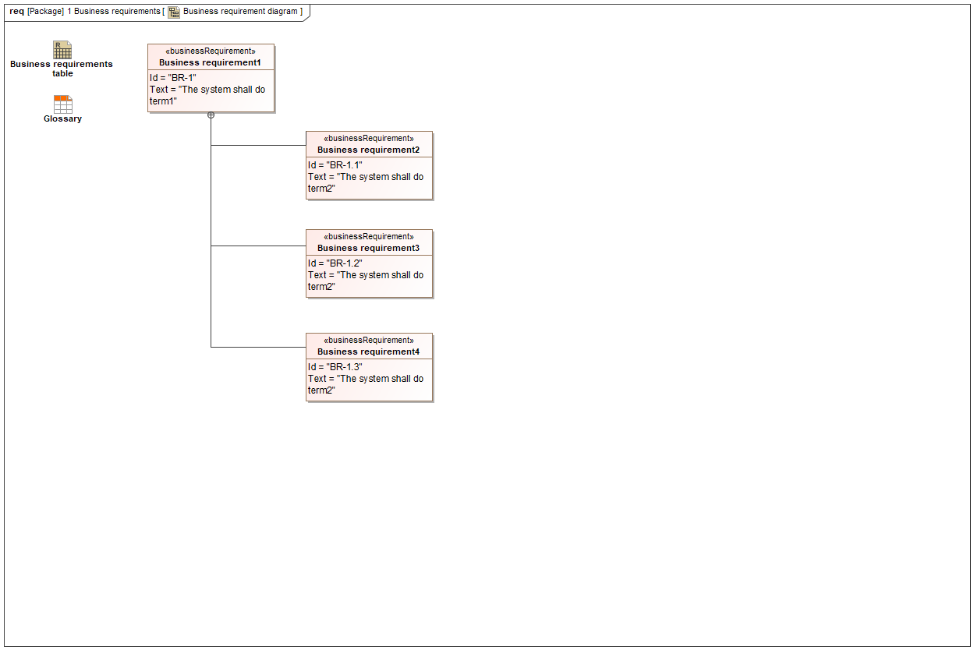

1. Business requirement diagram

## Business requirements table

NA

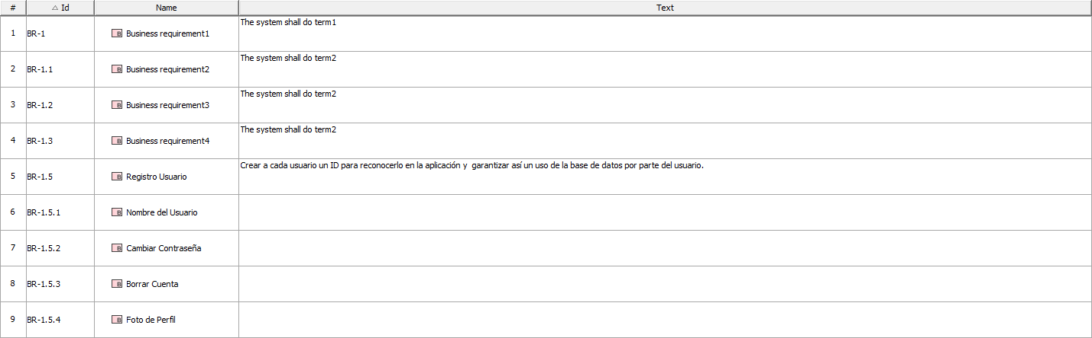

1. Business requirements table